Table of Contents

**INTRODUCTION** 2

**WEBPAGES** 3

**HOMEPAGE** 3

**MAURITIUS PAGE** 5

**ACCESSING PAGES THROUGH THE DROPDOWN MENU** 7

**GEOGRAPHY & LOCATION PAGE** 8

**CULTURE & PEOPLE PAGE** 10

**HISTORY PAGE** 12

**WEATHER & CLIMATE** 14

**CURRENCY PAGE** 16

**WHAT TO SEE** 18

**WHAT TO DO** 20

**ACTIVITIES** 21

**SHOPPING & RESTAURANT PAGE** 23

**WHERE TO STAY PAGE** 25

**CONTACT US PAGE** 27

**MY ACCOUNT PAGE** 29

**TESTING** 32

**HTML5 TAGS** 43

**CSS3** 52

**JAVASCRIPT** 53

**JQUERY** 55

**Conclusion** 57

**References** 58

**PARADISE WEBSITE REPORT**

# **INTRODUCTION**

Paradise is an organization whose main aim is to provide maximum information about our island, Mauritius.

We want to provide the information required to the foreigners while visiting our island. This website will demonstrate how it will facilitate them to discover Mauritius.

Paradise has been development using the framework Bootstrap, HTML5, CSS3, JavaScript and JQuery.

It consists of 13 webpages linked together.

Namely:

1. Index (Homepage)
2. Mauritius

* Geography & Location
* Culture & People
* History
* Weather & Climate
* Currency

1. What to see
2. What to do

* Activities
* Shopping & Restaurant

1. Where to stay
2. Contact us
3. My Account

# **WEBPAGES**

## **HOMEPAGE**

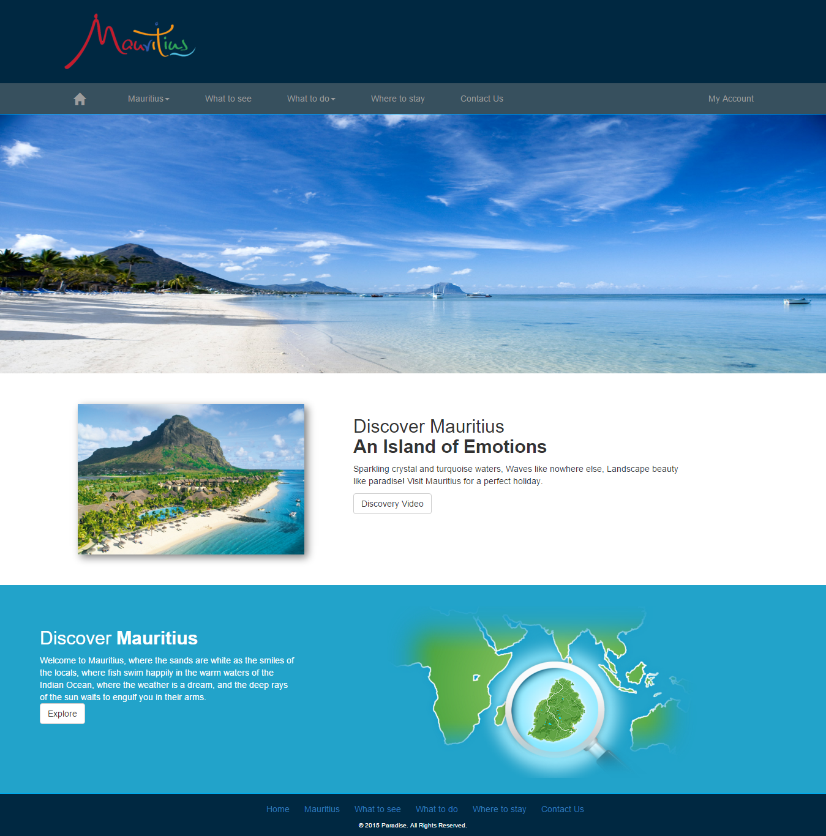

This is the interface of the Homepage. It consists of:

* Logo in the header part.
* The navigation bar where the user can navigate through the other pages.

It shows an effect while hovering on the navigation bar as shown below:

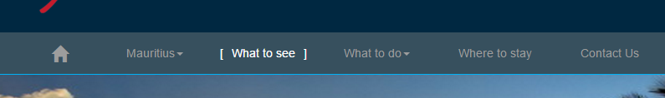

The effect has been implemented using JQuery.

* The slider, which shows different pictures one after another.
* A picture of Mauritius along with a discovery text under the slider.
* A Discovery Video button which will show a video when clicked. The video appears in light box using featherlight. JQuery and HTML5 tags have been used to make it display as shown.

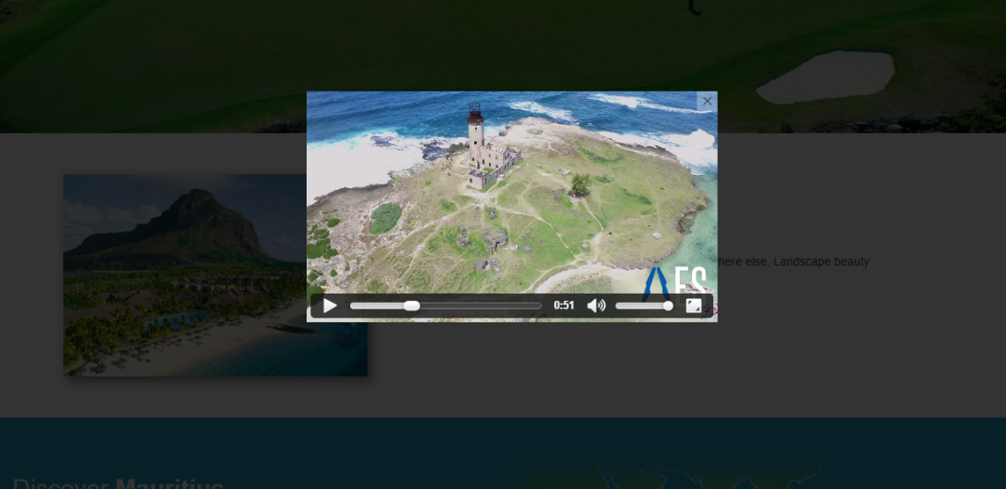

* Another text below the Discovery part, which shows a small text about Discover Mauritius.
* A button Explore, which is directed to page Mauritius when clicked.
* The footer part where the link of other pages and the copyright text are found.

## **MAURITIUS PAGE**

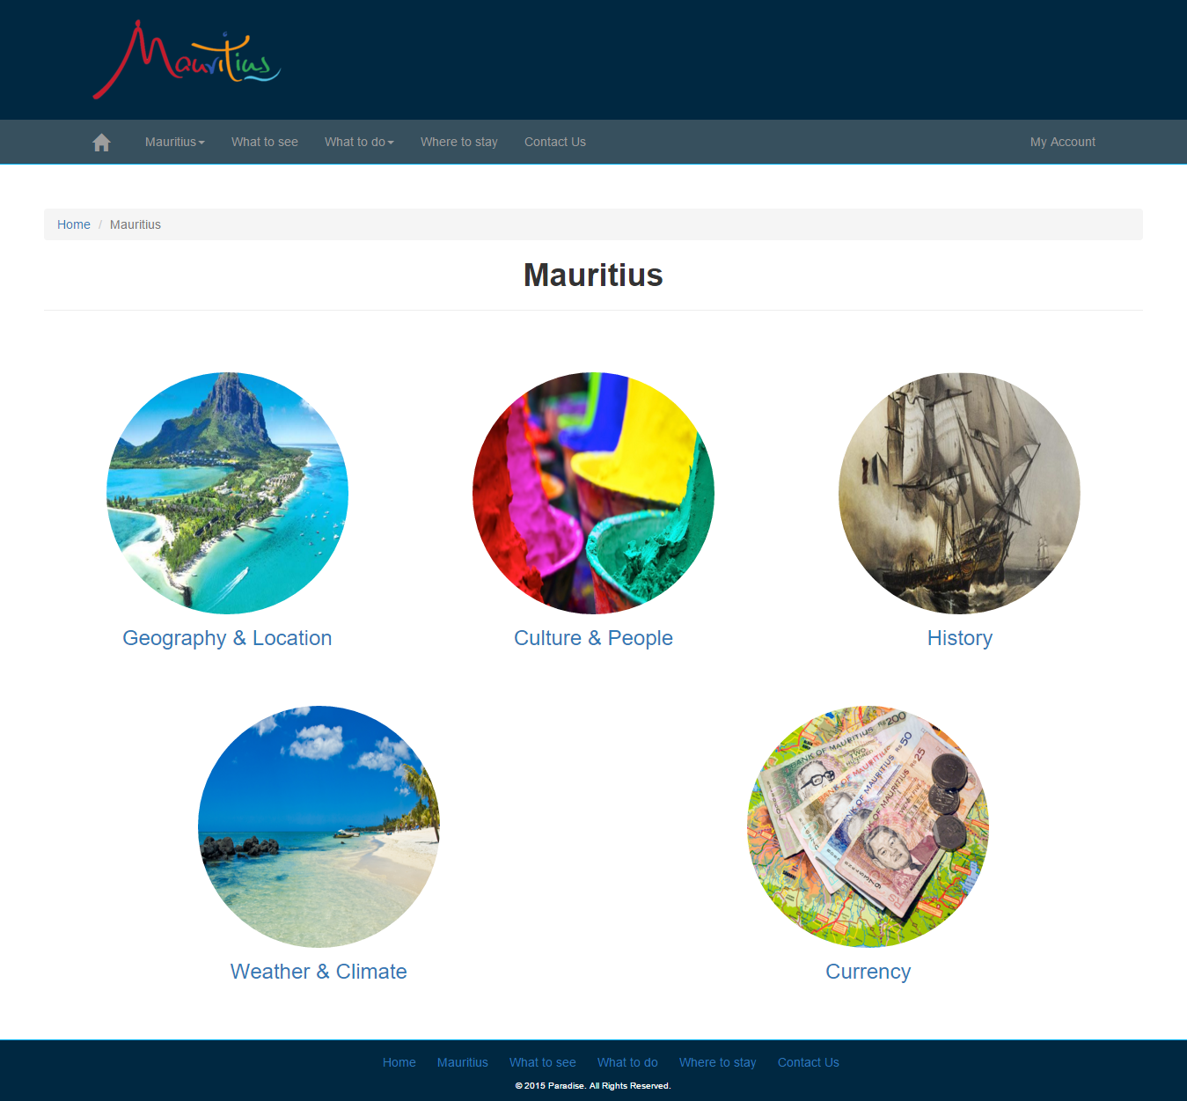

This is the Mauritius page which can be accessed in the footer. The header, navigation and the footer remains the same as the homepage. The webpage consists of:

* The breadcrumb which is below the navigation bar. It shows which page is active now. The Mauritius page is active, so it is grey. The user can navigate to the home page, by clicking Home in blue in the breadcrumb.

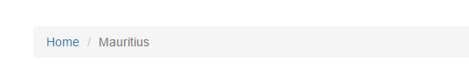

* A picture of Geography & Location along with the link which will be directed to Geography & Location page.
* A picture of Culture & People along with the link which will be directed to Culture & People page.
* A picture of History along with the link which will be directed to History page
* A picture of Weather & Climate along with the link which will be directed Weather & Climate page.
* A picture of Mauritian Currency along with the link which will be directed to Currency page.

## **ACCESSING PAGES THROUGH THE DROPDOWN MENU**

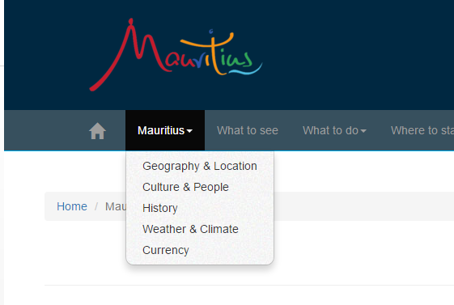

The page Geography & Location, Culture & People, History, Weather & Climate or Currency can chosen through the dropdown menu in the navigation part.

## **GEOGRAPHY & LOCATION PAGE**

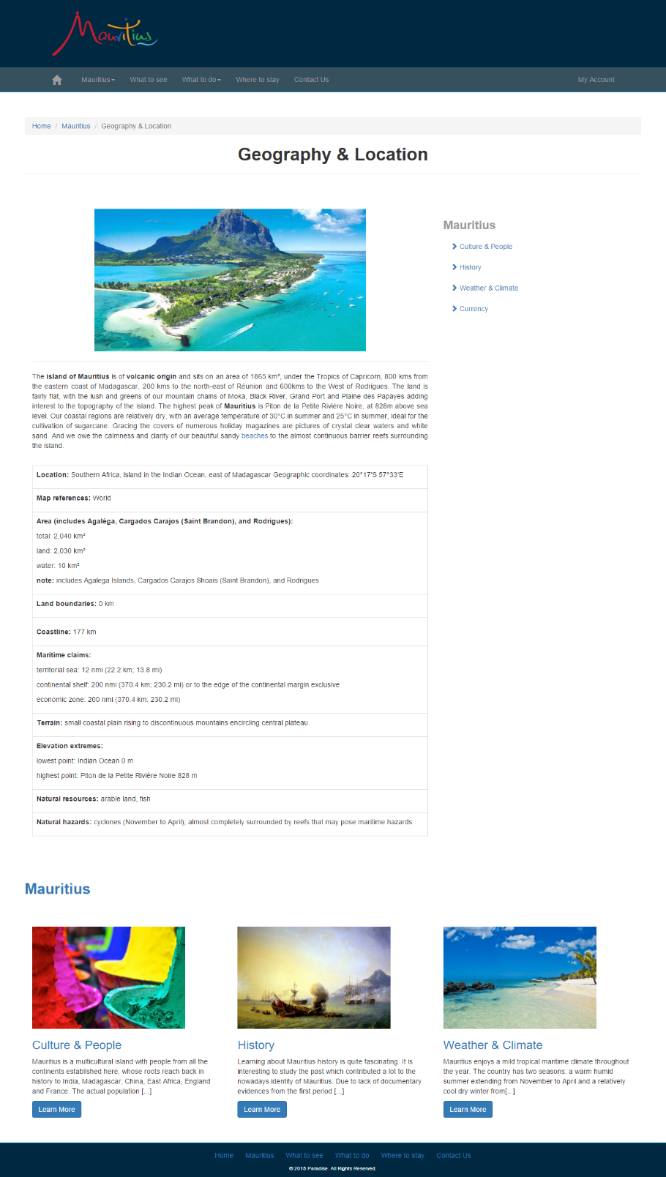

This is the Geography & Location page which has been accessed through the dropdown menu as shown above. The header, navigation and the footer remains the same as the homepage. The webpage consists of:

* The breadcrumb which is below the navigation bar. It shows which page is active now. The Geography & Location page is active, so it is grey. The user can navigate to the home page or Mauritius webpage, by clicking Home or Mauritius in blue in the breadcrumb.
* A picture in the center
* The details and a table of the geographical location of Mauritius
* A side bar, next to the picture of Geography & Location. It shows the other pages which is in the drop down menu. It can be accessed by the user for fast navigation
* Culture & People
* History
* Weather & Climate
* Currency
* The other pages as listed above found in the dropdown menu along with a small description below the details of the geographical location of Mauritius. They can be accessed by clicking the Learn More button or the name for more details.

## **CULTURE & PEOPLE PAGE**

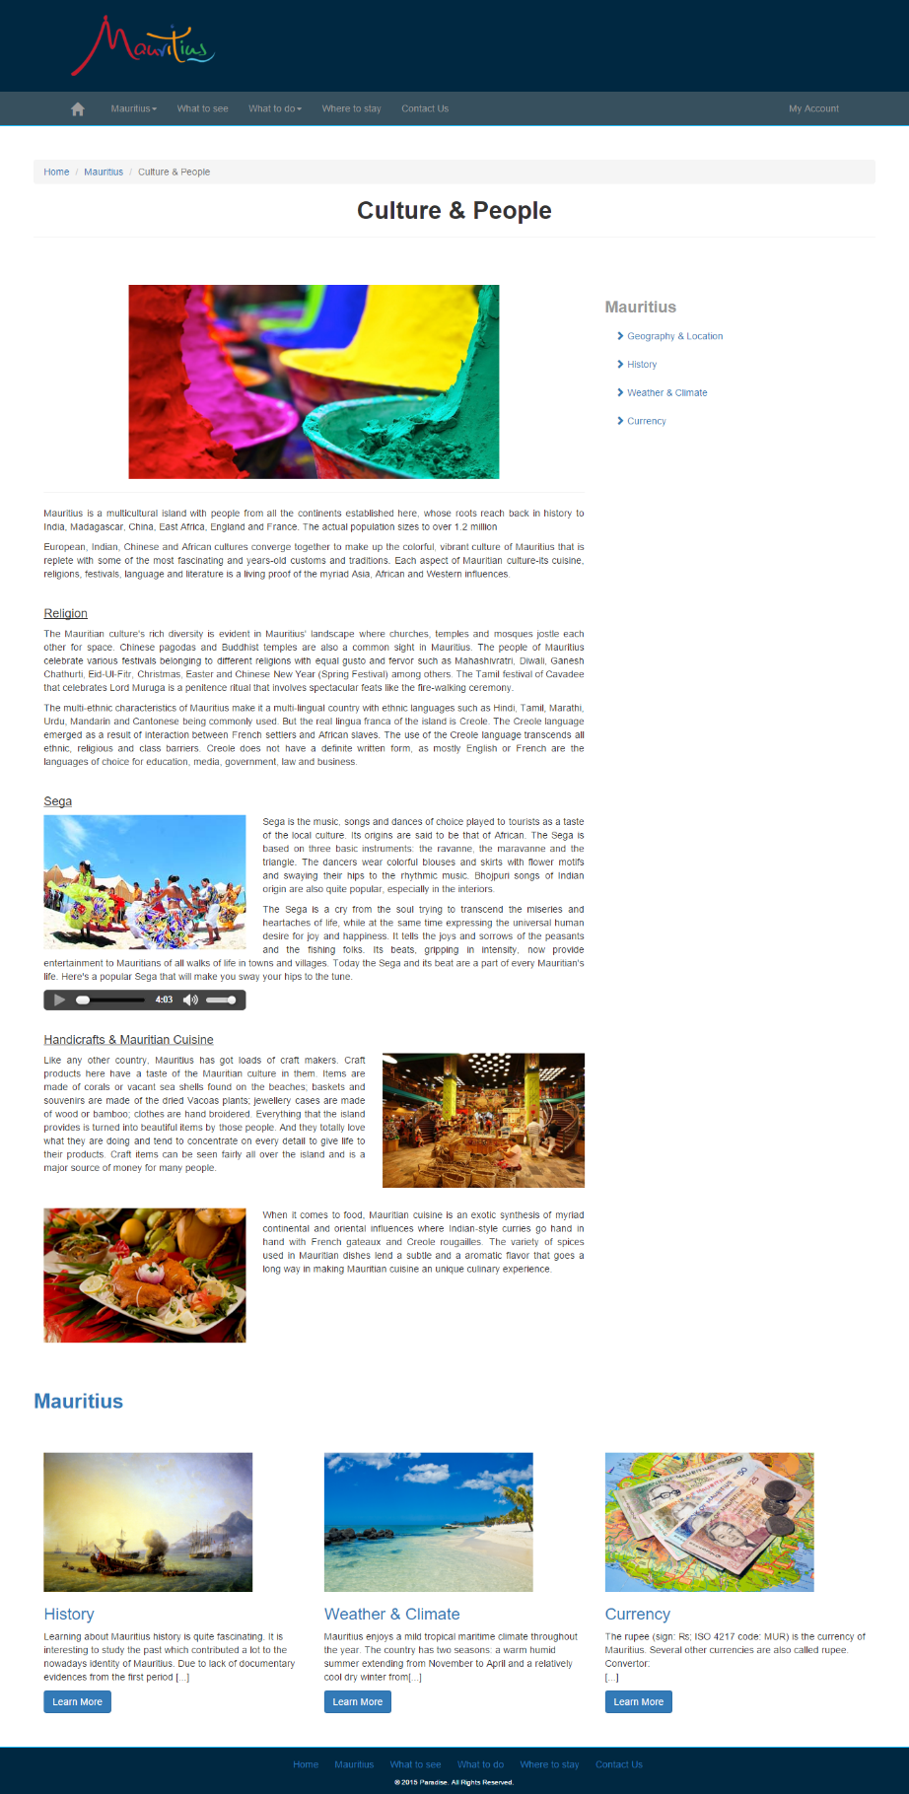

This is the Culture & People page which has been accessed through the dropdown menu as shown above. The header, navigation and the footer remains the same as the homepage. The webpage consists of:

* The breadcrumb which is below the navigation bar. It shows which page is active now. The Culture & People page is active, so it is grey. The user can navigate to the home page or Mauritius webpage, by clicking Home or Mauritius in blue in the breadcrumb.
* A picture in the center
* The details of the culture of Mauritius are described with pictures
* An audio below the description of Sega, which will play a Sega Music

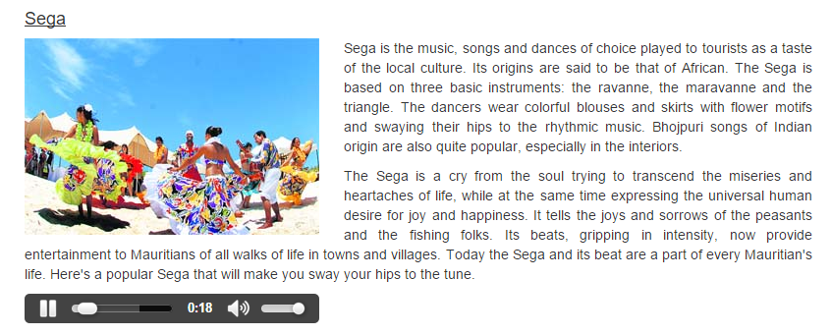

* A side bar, next to the picture of Culture & People. It shows the other pages which is in the drop down menu. It can be accessed by the user for fast navigation
* Geography & Location
* History
* Weather & Climate
* Currency
* The other pages as listed above found in the dropdown menu along with a small description below the details of the culture of Mauritius. They can be accessed by clicking the Learn More button or the name for more details.

## **HISTORY PAGE**

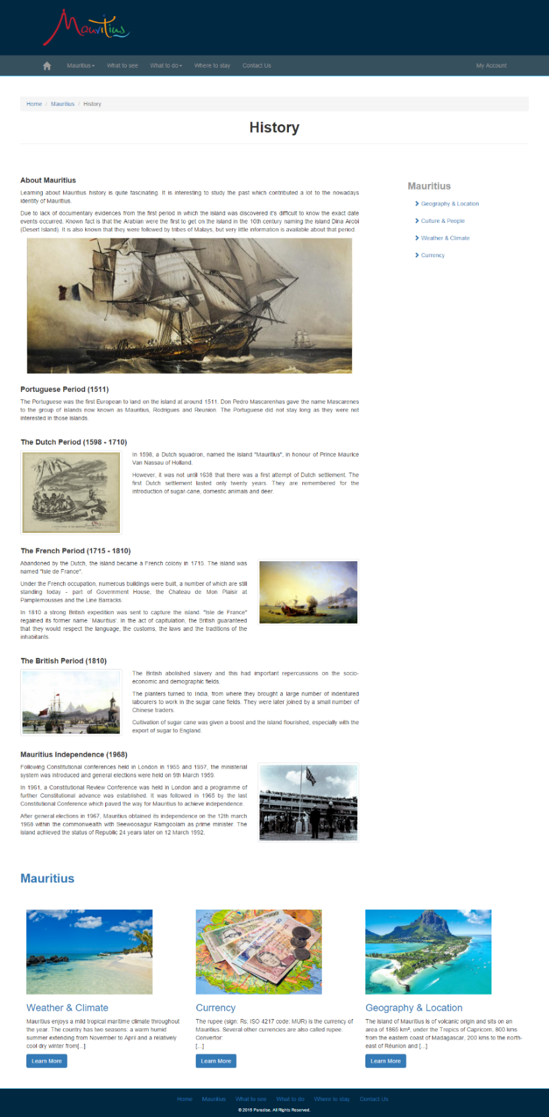

This is the History page which has been accessed through the dropdown menu as shown above. The header, navigation and the footer remains the same as the homepage. The webpage consists of:

* The breadcrumb which is below the navigation bar. It shows which page is active now. The History page is active, so it is grey. The user can navigate to the home page or Mauritius webpage, by clicking Home or Mauritius in blue in the breadcrumb.
* A picture in the center
* The details and the year of the period of Mauritius are described along with pictures.
* A side bar, next to the picture of History. It shows the other pages which is in the drop down menu. It can be accessed by the user for fast navigation
* Geography & Location
* Culture & People
* Weather & Climate
* Currency
* The other pages as listed above found in the dropdown menu along with a small description below the details of the history of Mauritius. They can be accessed by clicking the Learn More button or the name for more details.

## **WEATHER & CLIMATE**

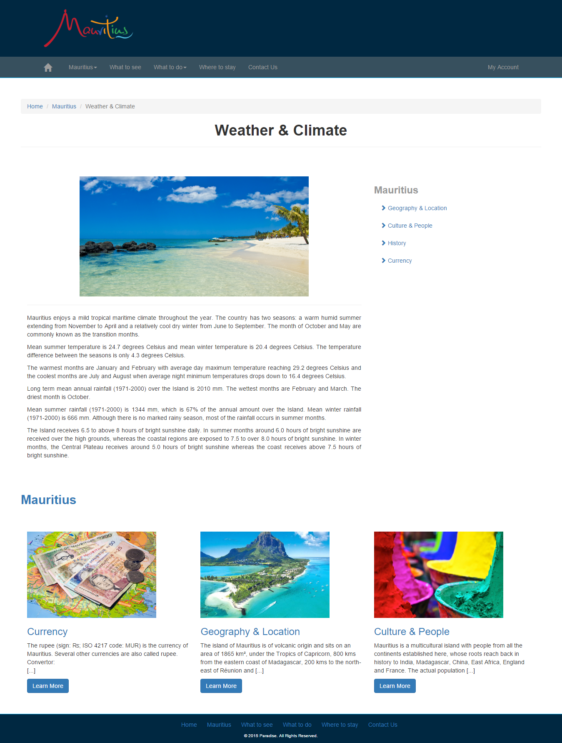

This is the Weather & Climate page which has been accessed through the dropdown menu as shown above. The header, navigation and the footer remains the same as the homepage. The webpage consists of:

* The breadcrumb which is below the navigation bar. It shows which page is active now. The Weather & Climate page is active, so it is grey. The user can navigate to the home page or Mauritius webpage, by clicking Home or Mauritius in blue in the breadcrumb.
* A picture in the center
* The details of the weather of Mauritius.
* A side bar, next to the picture of Weather & Climate. It shows the other pages which is in the drop down menu. It can be accessed by the user for fast navigation
* Geography & Location
* Culture & People
* History
* Currency
* The other pages as listed above found in the dropdown menu along with a small description below the details of the weather of Mauritius. They can be accessed by clicking the Learn More button or the name for more details.

## **CURRENCY PAGE**

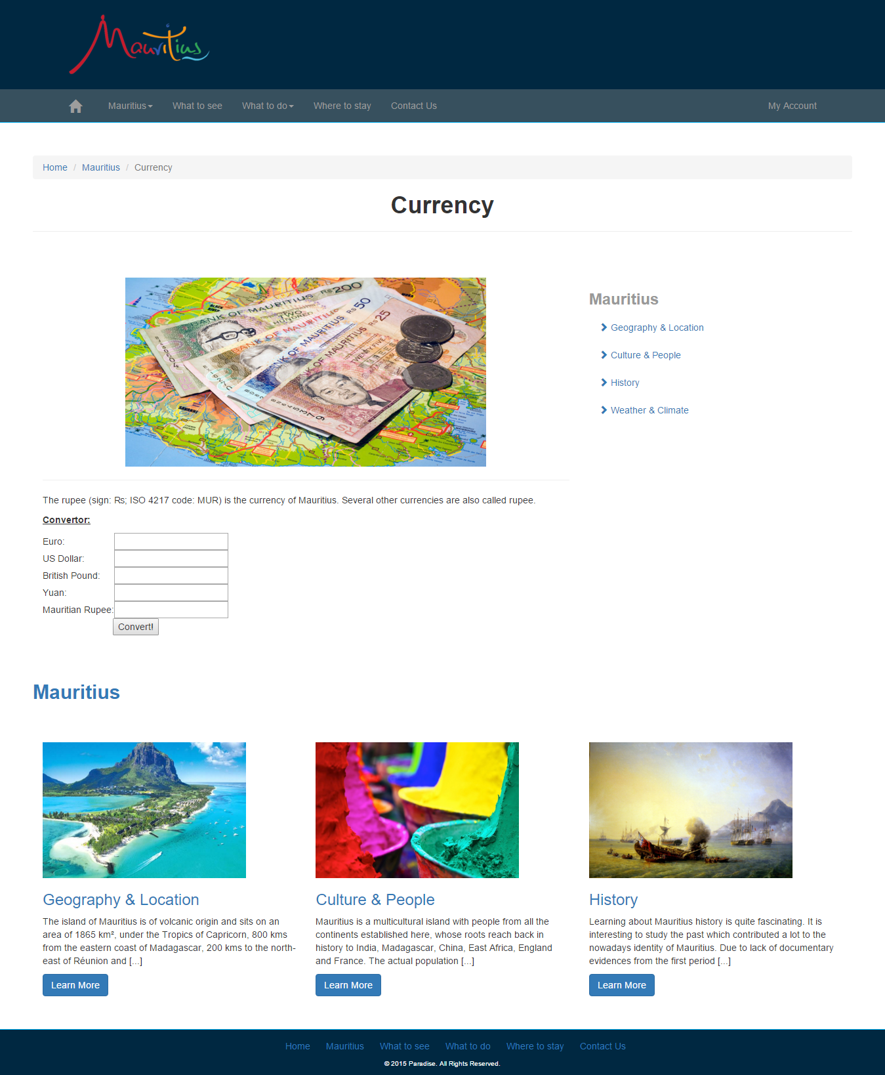

This is the Currency page which has been accessed through the dropdown menu as shown above. The header, navigation and the footer remains the same as the homepage. The webpage consists of:

* The breadcrumb which is below the navigation bar. It shows which page is active now. The Currency page is active, so it is grey. The user can navigate to the home page or Mauritius webpage, by clicking Home or Mauritius in blue in the breadcrumb.
* A picture in the center
* The converter which will allow the user to enter a value in any of the field, i.e. Euro, British Pound, Yuan or Mauritian Rupee, it will convert it to give the amount for Euro, British Pound, Yuan and Mauritius Currency. It has used JavaScript to calculate it.

e.g.

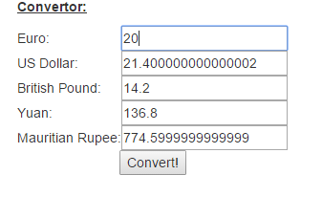

The amount 20 has been entered in the Euro field and it has displayed the converted amount in the other fields.

* A side bar, next to the picture of Currency. It shows the other pages which is in the drop down menu. It can be accessed by the user for fast navigation
* Geography & Location
* Culture & People
* History
* Weather & Climate

* The other pages as listed above found in the dropdown menu along with a small description below the converter of currency. They can be accessed by clicking the Learn More button or the name for more details.

## **WHAT TO SEE**

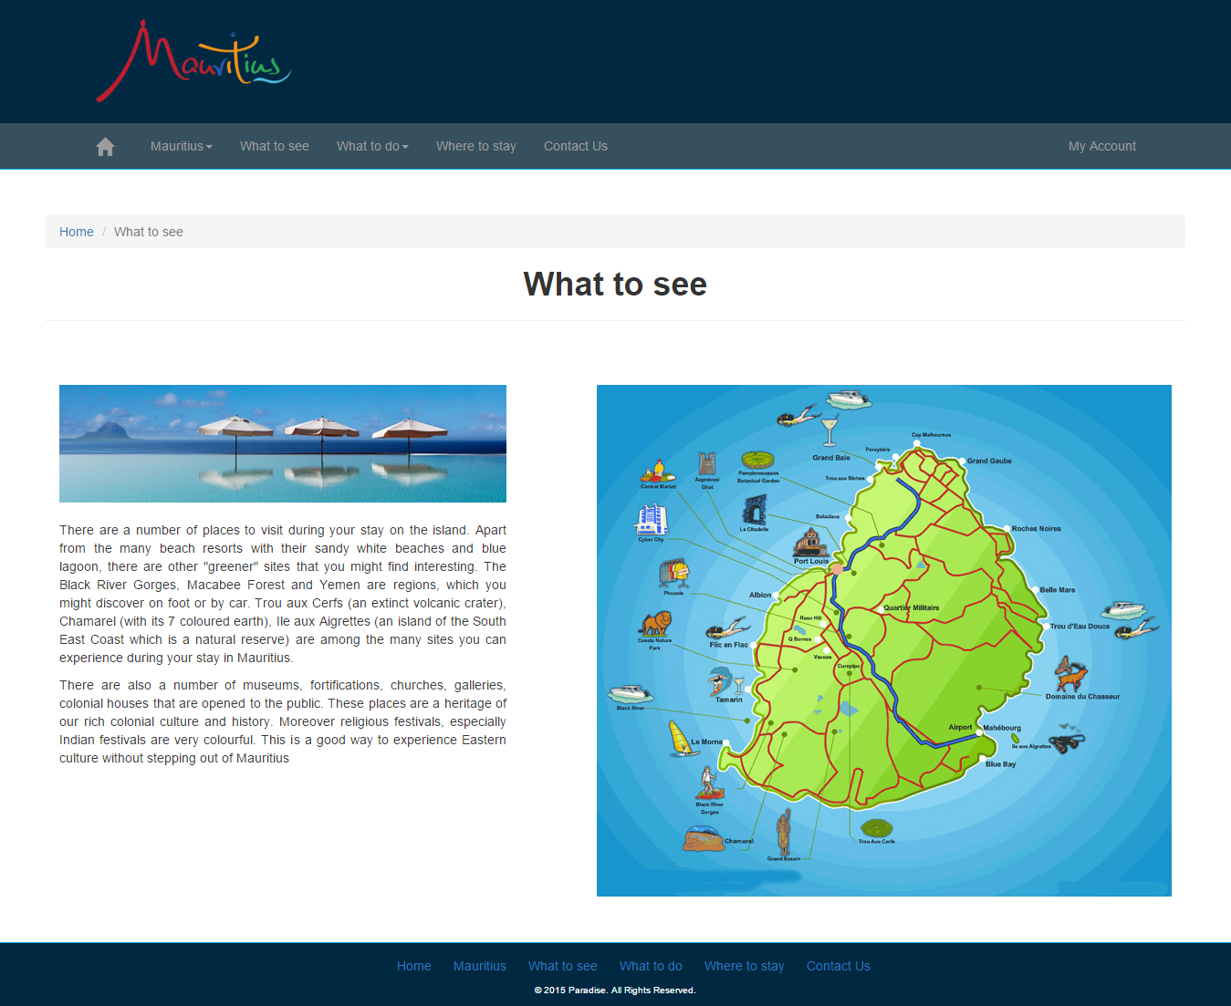

This is the What to See page which has been accessed in the navigation bar or in the footer. The header, navigation and the footer remains the same as the homepage. The webpage consists of:

* The breadcrumb which is below the navigation bar. It shows which page is active now. The What to See page is active, so it is grey. The user can navigate to the Homepage, by clicking Home in blue in the breadcrumb.
* A picture has been set in the right of the page.
* A description about what need to be see in Mauritius.
* Details of each part of the picture which will be displayed while clicking on the small drawings on the picture.

Image Mapping has been used to do so.

E.g.

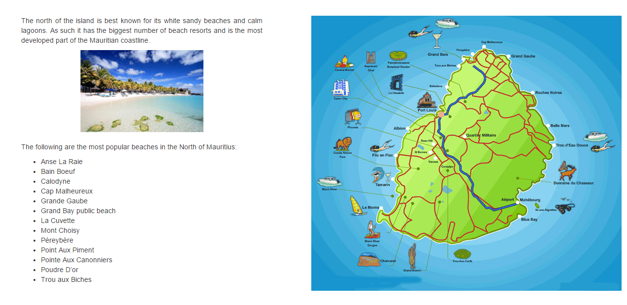

The boat which is found in the North of the map of Mauritius has been clicked

The description about the beaches in the North of Mauritius has been displayed in the left side of the page.

The same applies for the other part of the picture that will be clicked. The current text in the left side of the page will fade out so as to give new description about another part of the island, by fading in the text and pictures.

## **WHAT TO DO**

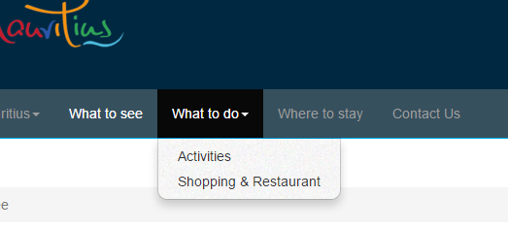

The page Activities or Shopping & Restaurant can be chosen through the dropdown menu of What to do in the navigation part.

## **ACTIVITIES**

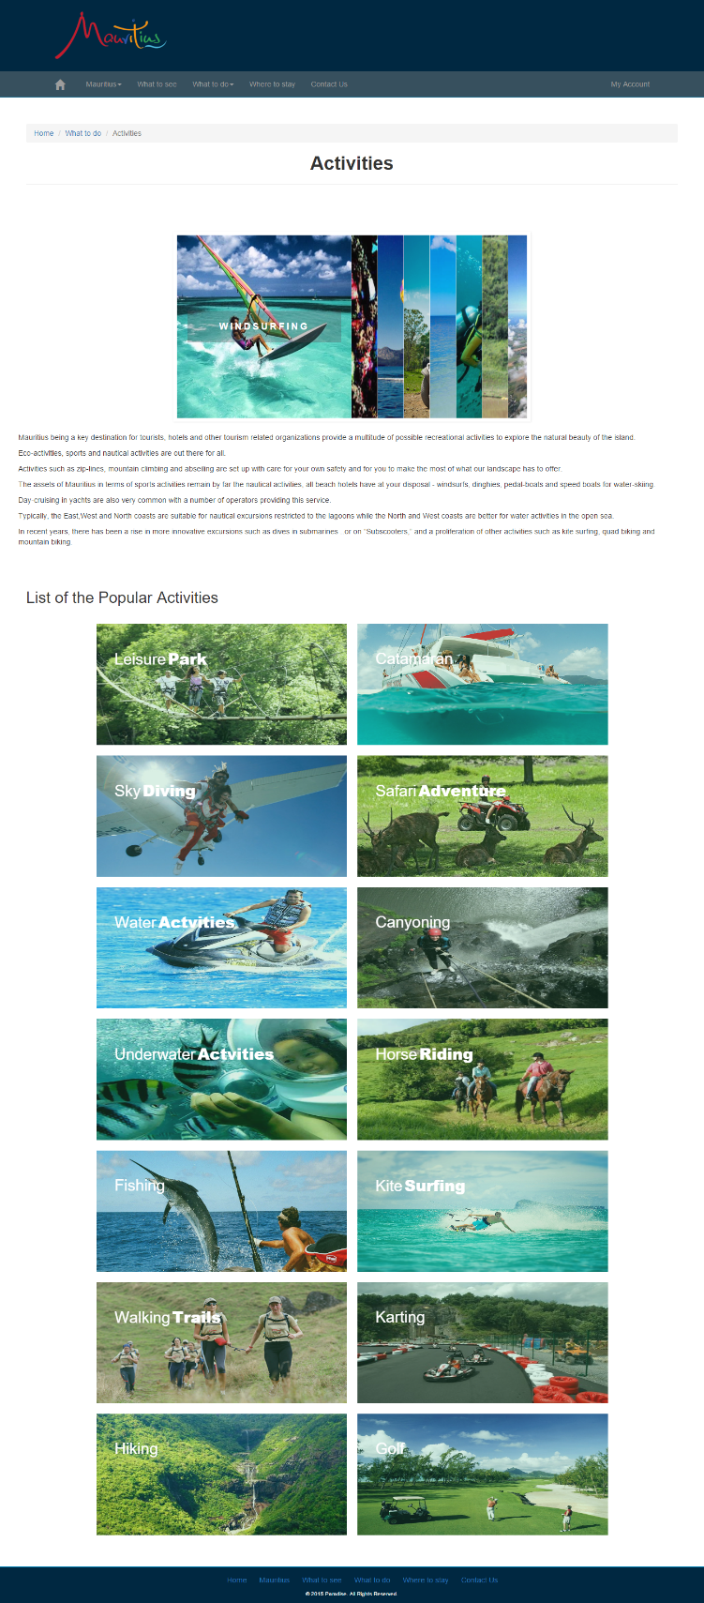

This is the Activities page which has been accessed in the dropdown menu of What to do as shown above. The header, navigation and the footer remains the same as the homepage. The webpage consists of:

* The breadcrumb which is below the navigation bar. It shows which page is active now. The Activities page is active, so it is grey. The user can navigate to the Homepage or What to do, by clicking Home or What to do in blue in the breadcrumb.
* A slider with the name of the activities is set in the center, below the breadcrumb as shown
* The description of the overall activities available in a small paragraph
* The list of the some of the popular activities available is displayed.
* A small description about each activities can be seen while hovering over the picture. It has been done using JQuery.

e.g.

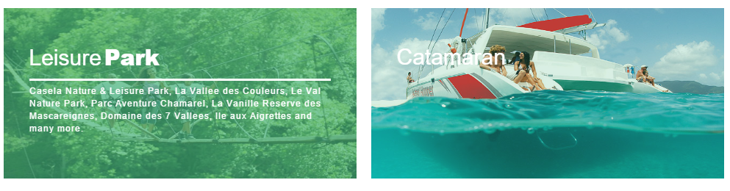

The details of Leisure Park has been displayed when it has been hovered.

Unlike the Catamaran, the details has not been displayed since it has not been hovered.

## **SHOPPING & RESTAURANT PAGE**

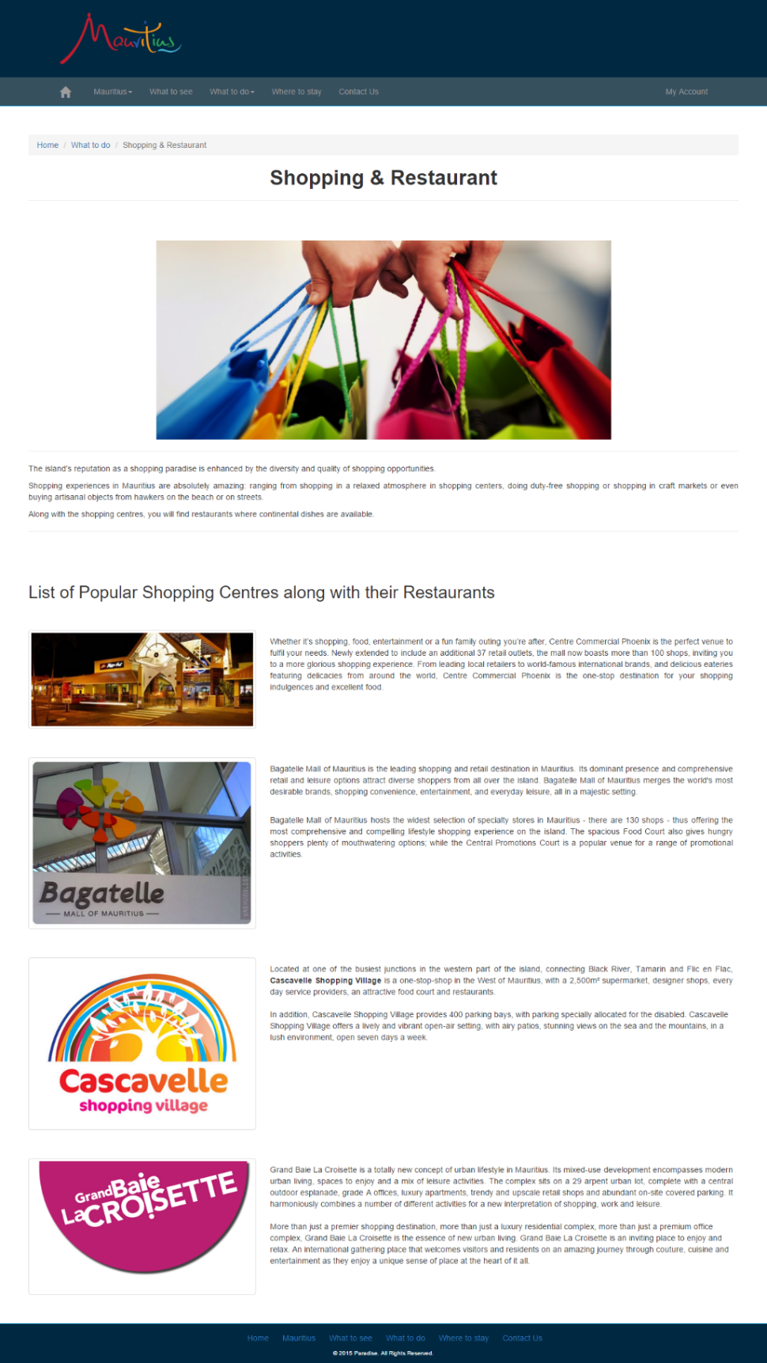

This is the Shopping & Restaurant page which has been accessed in the dropdown menu of What to do as shown above. The header, navigation and the footer remains the same as the homepage. The webpage consists of:

* The breadcrumb which is below the navigation bar. It shows which page is active now. The Shopping & Restaurant page is active, so it is grey. The user can navigate to the Homepage or What to do webpage, by clicking Home or What to do in blue in the breadcrumb.
* The shopping and restaurant atmosphere in Mauritius are described in a small paragraph.
* The list of the some of the popular malls in Mauritius and their descriptions.

## **WHERE TO STAY PAGE**

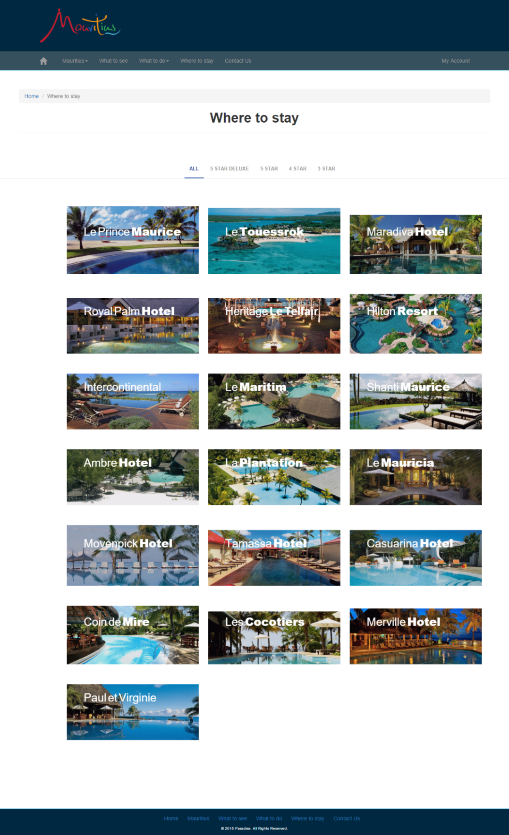

This is the Where to stay page which has been accessed in the navigation bar. The header, navigation and the footer remains the same as the homepage. The webpage consists of:

* The breadcrumb which is below the navigation bar. It shows which page is active now. The Where to stay page is active, so it is grey. The user can navigate to the Homepage, by clicking Home in blue in the breadcrumb.
* The hotels which has been displayed by category.
* All – shows all the hotels
* 5 Star Deluxe – hotels in 5 Star Deluxe category
* 5 Star – hotels in 5 Star category
* 4 Star – hotels in 4 Star category
* 3 Star – hotels in 3 Star category

When a category is selected, it shows an effect of shuffling the images.

* The star of the hotels which can be found on the picture while hovering on the pictures.

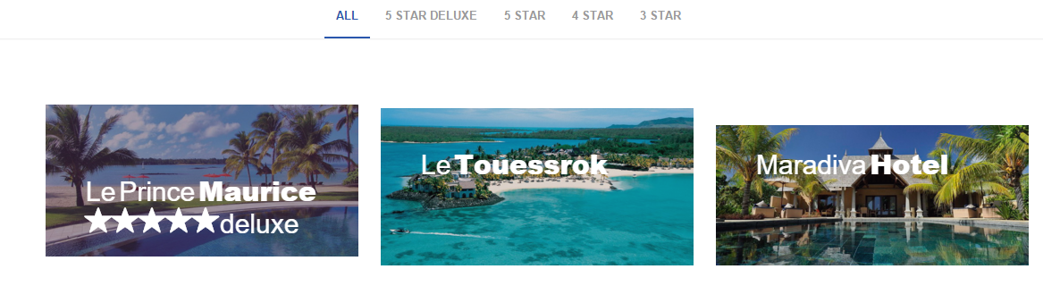

On the picture Le Prince Maurice, the standard, i.e. the star of the hotel can be seen since it has been hovered.

JQuery has been used to implement these effects.

## **CONTACT US PAGE**

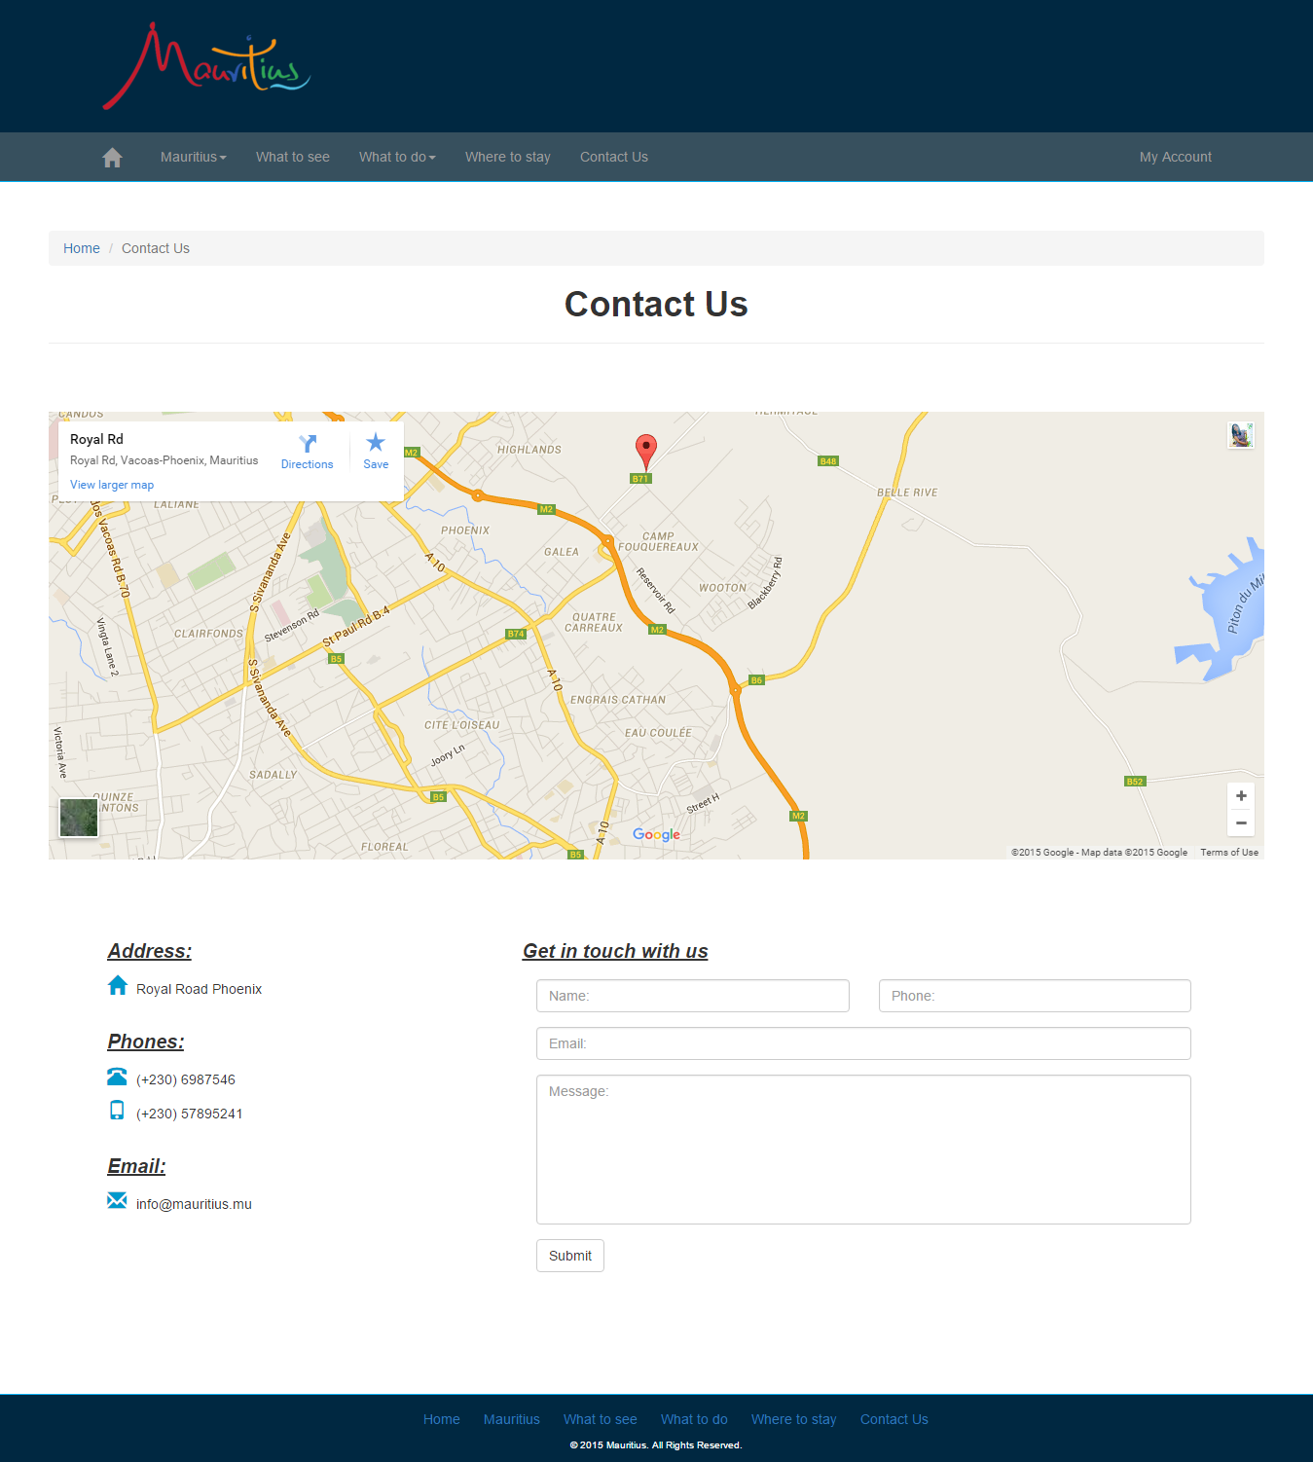

This is the Contact Us page which has been accessed in the navigation bar. The header, navigation and the footer remains the same as the homepage. The webpage consists of:

* The breadcrumb which is below the navigation bar. It shows which page is active now. The Contact Us is active, so it is grey. The user can navigate to the Homepage, by clicking Home in blue in the breadcrumb.
* A Google Map, which indicates the location of Paradise.
* The address, phone numbers and email address in the left side of the page
* A form, Get in touch with us, through which a user can get in touch with us for more queries.

## **MY ACCOUNT PAGE**

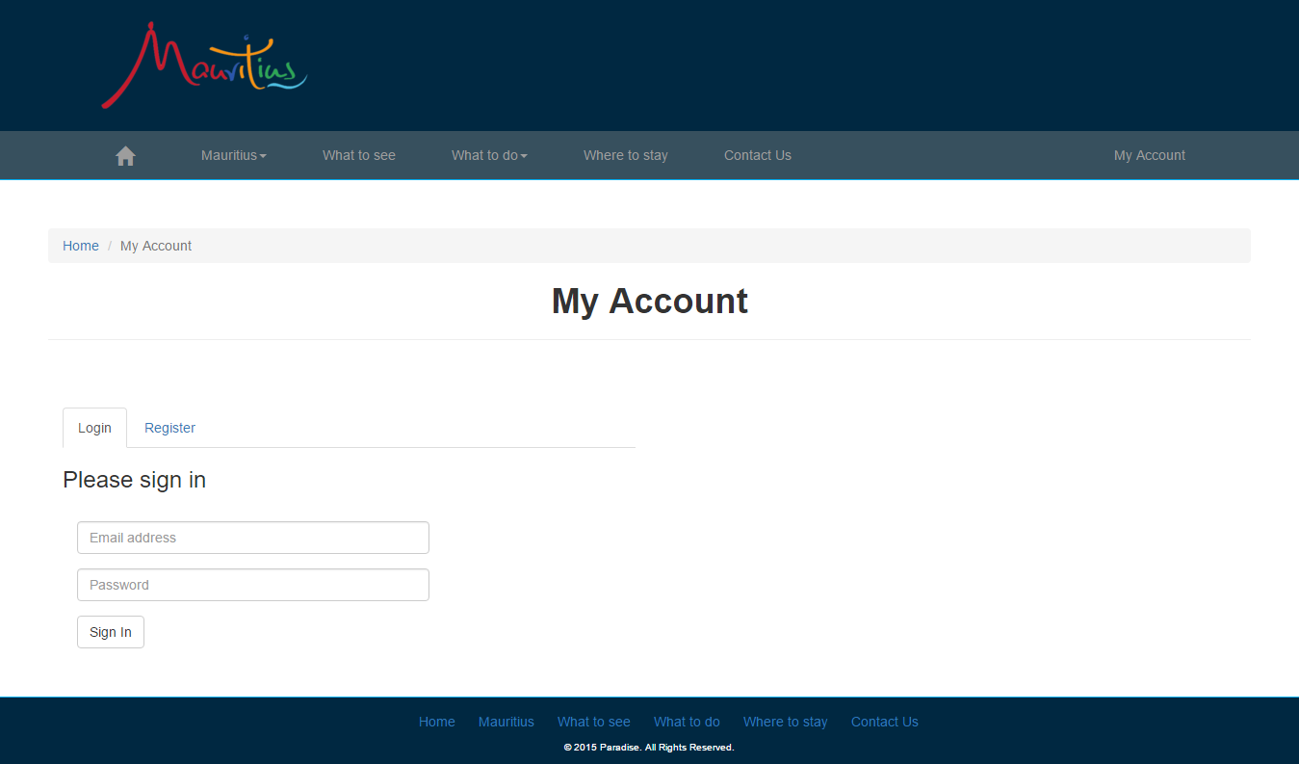

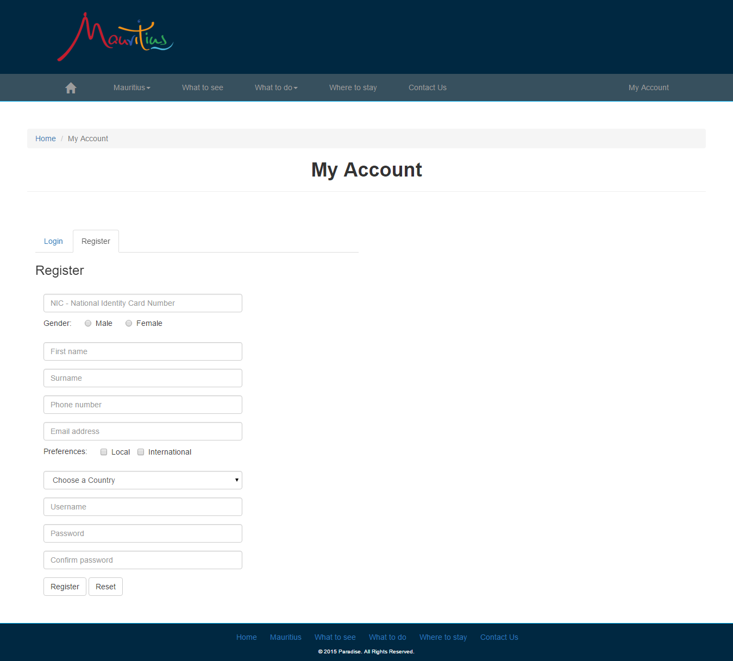

This is the My Account page which has been accessed in the right of the navigation bar. The header, navigation and the footer remains the same as the homepage. The webpage consists of:

* Tabs which contain the Login Form and the Registration Form as shown above.
* The fields where the user will have to enter their details to login to the page or to register himself/herself.
* This page contains validations. If ever the wrong data is being entered or a field has not been filled, it will not proceed to submit/sign in.

The validations have been made using the JQuery.

It is as shown below:

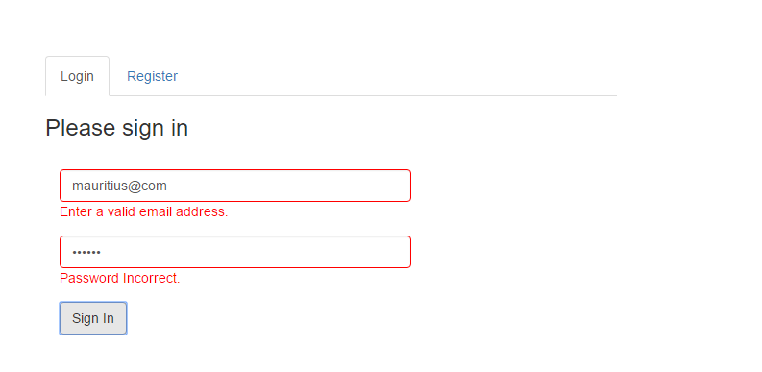

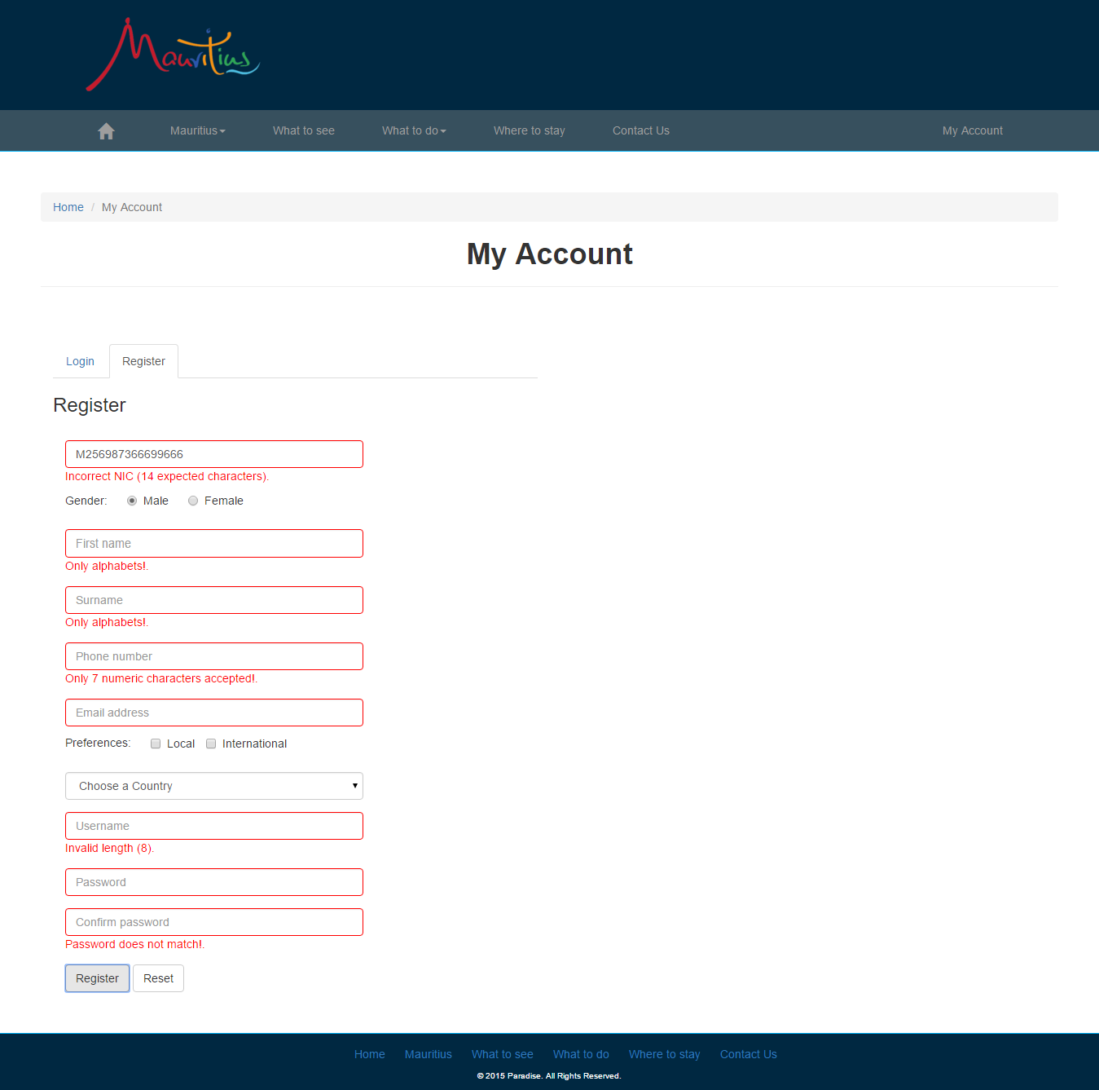

# **TESTING**

The website has been tested to detect if there has still been errors after implementing it.

**Home Page**

|  |  |  |
| --- | --- | --- |
| **To be Tested** | **Expected Result** | **Meet Expectation?** |
| Navigation Buttons on Navigation Bar | The page clicked should be load. The dropdown menu should display the required pages and should be loaded when selected |  |
| Slideshow | The slideshow should show the different pictures without having to be clicked, automated slideshow |  |
| Discovery Video Button | A video should be opened when the Discovery Video button is clicked |  |
| Explore Button | When the Explore button is clicked, it should direct the user to the page Mauritius |  |
| Footer links | The required page should be opened when one of link is clicked. |  |
| Pictures | The pictures should be loaded without any disturbance of pixel |  |

**Geography & Location webpage**

|  |  |  |
| --- | --- | --- |
| **To be Tested** | **Expected Result** | **Meet Expectation?** |
| Pictures | The pictures should be loaded without any disturbance of pixel |  |
| Bread Crumbs | The page which is active, i.e. Geography & Location, should be grey. The other links, Home and Mauritius, in the breadcrumb should be directed to their appropriate webpage when clicked. |  |
| Side Bar | The links in the sidebar should be directed to their appropriate webpage when clicked |  |
| Learn More Button | The Learn More button under each text should direct the user to the one chosen. I.e. Learn More under Culture & People, should direct them to Culture webpage. It applies the same for the other Learn More button |  |
| Links under each Picture | The link under each picture should be directed to the appropriate webpage when clicked |  |

**Culture & People webpage**

|  |  |  |
| --- | --- | --- |
| **To be Tested** | **Expected Result** | **Meet Expectation?** |
| Pictures | The pictures should be loaded without any disturbance of pixel |  |
| Bread Crumbs | The page which is active, i.e. Culture & People, should be grey. The other links, Home and Mauritius, in the breadcrumb should be directed to their appropriate webpage when clicked. |  |
| Side Bar | The links in the sidebar should be directed to their appropriate webpage when clicked |  |
| Audio | The audio of in the description Sega should play when it is selected to be played |  |
| Learn More Button | The Learn More button under each text should direct the user to the one chosen. I.e. Learn More under History, should direct them to History webpage. It applies the same for the other Learn More button |  |
| Links under each Picture | The link under each picture should be directed to the appropriate webpage when clicked |  |

**History Webpage**

|  |  |  |
| --- | --- | --- |
| **To be Tested** | **Expected Result** | **Meet Expectation?** |
| Pictures | The pictures should be loaded without any disturbance of pixel |  |
| Bread Crumbs | The page which is active, i.e. History, should be grey. The other links, Home and Mauritius, in the breadcrumb should be directed to their appropriate webpage when clicked. |  |
| Side Bar | The links in the sidebar should be directed to their appropriate webpage when clicked |  |
| Learn More Button | The Learn More button under each text should direct the user to the one chosen. I.e. Learn More under Weather & Climate, should direct them to Weather & Climate webpage. It applies the same for the other Learn More button |  |
| Links under each Picture | The link under each picture should be directed to the appropriate webpage when clicked |  |

**Weather & Climate Webpage**

|  |  |  |
| --- | --- | --- |
| **To be Tested** | **Expected Result** | **Meet Expectation?** |
| Pictures | The pictures should be loaded without any disturbance of pixel |  |
| Bread Crumbs | The page which is active, i.e. Weather & Climate, should be grey. The other links, Home and Mauritius, in the breadcrumb should be directed to their appropriate webpage when clicked. |  |
| Side Bar | The links in the sidebar should be directed to their appropriate webpage when clicked |  |
| Learn More Button | The Learn More button under each text should direct the user to the one chosen. I.e. Learn More under Currency, should direct them to Currency webpage. It applies the same for the other Learn More button |  |
| Links under each Picture | The link under each picture should be directed to the appropriate webpage when clicked |  |

**Currency Webpage**

|  |  |  |
| --- | --- | --- |
| **To be Tested** | **Expected Result** | **Meet Expectation?** |
| Pictures | The pictures should be loaded without any disturbance of pixel |  |
| Bread Crumbs | The page which is active, i.e. Currency, should be grey. The other links, Home and Mauritius, in the breadcrumb should be directed to their appropriate webpage when clicked. |  |
| Side Bar | The links in the sidebar should be directed to their appropriate webpage when clicked |  |
| Convertor | The convertor should convert the amount inserted in one field and display it in the other fields |  |
| Learn More Button | The Learn More button under each text should direct the user to the one chosen. I.e. Learn More under Geography & Location, should direct them to Geography & Location webpage. It applies the same for the other Learn More button |  |
| Links under each Picture | The link under each picture should be directed to the appropriate webpage when clicked |  |

**What to see Webpage**

|  |  |  |
| --- | --- | --- |
| **To be Tested** | **Expected Result** | **Meet Expectation?** |
| Pictures | The pictures should be loaded without any disturbance of pixel |  |
| Bread Crumbs | The page which is active, i.e. What to see, should be grey. The other link, Home, in the breadcrumb should be directed to their appropriate webpage when clicked. |  |
| Text and Picture | The default text and pictures should be displayed when What to see webpage is opened before clicking on the map of Mauritius |  |
| Image Map | When different parts on the map of Mauritius is clicked, description of the clicked area should be displayed in the left side of the Map of Mauritius.  When another area is clicked, the description should fade out to show the other description |  |

**Activities Webpage**

|  |  |  |
| --- | --- | --- |
| **To be Tested** | **Expected Result** | **Meet Expectation?** |
| Bread Crumbs | The page which is active, i.e. Activities, should be grey. The other links, Home and What to do, in the breadcrumb should be directed to their appropriate webpage when clicked. |  |
| Slider | The slider should show 8 different pictures.  When the part of visible of the next picture is clicked, it should float to left showing the image full along with a caption i.e. the activity name. It also applies for the rest pictures |  |
| Pictures in the list of activities | It should display 14 pictures along with caption on the pictures.  When hovering on the pictures, a short description of the activity should be displayed. It applies for all the 14 pictures. |  |

**Shopping & Restaurant Webpage**

|  |  |  |
| --- | --- | --- |
| **To be Tested** | **Expected Result** | **Meet Expectation?** |
| Pictures | The pictures should be loaded without any disturbance of pixel |  |
| Bread Crumbs | The page which is active, i.e. Shopping & Restaurant, should be grey. The other link, Home and What to do, in the breadcrumb should be directed to their appropriate webpage when clicked. |  |

**Where to stay Webpage**

|  |  |  |
| --- | --- | --- |
| **To be Tested** | **Expected Result** | **Meet Expectation?** |
| Bread Crumbs | The page which is active, i.e. Where to stay, should be grey. The other link, Home, in the breadcrumb should be directed to their appropriate webpage when clicked. |  |
| Hotels Pictures | The 19 pictures of the hotels should be displayed.  When hovering over the pictures, the stars in which the hotels are categorized should be displayed. |  |
| Category of the hotels | When the category of the hotel is selected, it should displayed only the hotels of the specified category. I.e. if 5 Star is selected, the pictures of only the 5 Star rated hotels will be displayed. The same applies for the other the stars.  It should also shows a shuffling effect while moving within the categories. |  |

**Contact Us Webpage**

|  |  |  |
| --- | --- | --- |
| **To be Tested** | **Expected Result** | **Meet Expectation?** |
| Google Map | The location should be displayed using Google Map |  |
| Get in touch form | The fields should allow entering of data |  |
| Submit Button | The submit button should accept the entered data |  |

**My Account Webpage**

* **Login**

|  |  |  |
| --- | --- | --- |
| **To be Tested** | **Expected Result** | **Meet Expectation?** |
| Email address field | The field should accept email in the format [user@domain.com](mailto:user@domain.com)  Error message should appear below the text box if any error |  |
| Password field | Should not be blank |  |
| Sign In Button | It should accept the data entered in Email address field and password. The Email address and password should be correctly entered  Error message should appear if any error Error message should appear below the text box if the condition above is not satisfied |  |

* **Register**

|  |  |  |
| --- | --- | --- |
| **To be Tested** | **Expected Result** | **Meet Expectation?** |
| NIC field | It should not be blank and should contain 14 characters  Error message should appear below the text box if the condition above is not satisfied |  |
| First Name | It should contain alphabets only  Error message should appear below the text box if the condition above is not satisfied |  |
| Surname | It should contain alphabets only  Error message should appear below the text box if the condition above is not satisfied |  |
| Phone Number | It should contain 7 numeric characters only  Error message should appear below the text box if the condition above is not satisfied |  |
| Email address field | The field should accept email in the format [user@domain.com](mailto:user@domain.com)  Error message should appear below the text box if the condition above is not satisfied |  |
| Choose a country | Should display a list of countries from which the required country can be chosen |  |
| Username | The username should be of length 8  Error message should appear below the text box if the condition above is not satisfied |  |
| Password | A password should be entered. Cannot be blank. |  |
| Confirm Password | The password entered in the Confirm Password field should match with the password entered in the Password field  Error message should appear below the text box if the condition above is not satisfied |  |
| Register Button | After the data has been entered correctly, when the Register button will be clicked, it will be directed to another page  If wrong data is entered the Registration button will not work, it will show the field with the errors instead |  |
| Reset Button | Should show a message of confirming to clear the data of the form.  The data must be cleared after clicked |  |

## **HTML5 TAGS**

|  |  |
| --- | --- |
| <div> | It defines a section of the webpage.  **Example:**  <div class="row content-head">  <ol class="breadcrumb">  <li><a href="index.html">Home</a></li>  <li><a href="#">What to do</a></li>  <li class="active">Activities</li>  </ol>    <h1 style="text-align:center;"><strong>Activities</strong></h1>    <hr>    </div> |
| <img> | Tag used to place the images in the webpage.  **Example:**  <div class="col-sm-6">  <img src="images/mrumap.png" width="510" height="290" alt="mrumap.png"/>  </div> |
| <nav> | Tag that has been used to do the navigation bar  **Example:**  <nav class="navbar navbar-inverse navbar-fixed-top menu-background-full cl-effect-1">  <div class="container">  <div class="navbar-header">  <button type="button" class="navbar-toggle collapsed" data-toggle="collapse" data-target="#navbar" aria-expanded="false" aria-controls="navbar">  <span class="sr-only">Toggle navigation</span>  <span class="icon-bar"></span>  …..  </div><!--/.navbar-collapse -->  </div>  </nav> |
| <button> | Tag to place button on the webpage  **Example:**  <div class="form-group">  <div class="col-sm-offset-0 col-sm-8">  <button type="submit" class="btn btn-default" id="btn_login">Sign In</button>  </div>  </div> |
| <a> | To link pages in the website  **Example:**  <a href="index.html">Home</a> |
| <ul> | To create unordered list  **Example:**  <ul>  <li><a href="index.html">Home</a></li>  <li><a href="mauritius.html">Mauritius</a></li>  …  </ul> |
| <li> | To define list  **Example:**  <li><a href="index.html">Home</a></li>  <li><a href="mauritius.html">Mauritius</a></li>  <li><a href="see.html">What to see</a></li> |
| <video> | To place video in the webpage  **Example:**  <video controls class="lightbox" width="500" height="281" id="fl4" style="border:none;" webkitallowfullscreen mozallowfullscreen allowfullscreen>  <source src="mauritius4k.mp4" type="video/mp4">  Your browser does not support the video tag.  </video> |
| <audio> | To place an audio in the webpage  **Example:**  <audio controls>  <source src="Tik Tiké.mp3" type="audio/mpeg">  </audio> |
| <footer> | To define the footer of the webpage  **Example:**  <footer>  <ul>  <li><a href="index.html">Home</a></li>  <li><a href="mauritius.html">Mauritius</a></li>  ...  </ul>  <p class="copyright">&copy; 2015 Paradise. All Rights Reserved.</p>  </footer> |
| <span> | To group in-line elements  **Example:**  <span class="icon-bar"></span> |
| <br> | To insert a line break  **Example:**  <audio controls>  <source src="Tik Tiké.mp3" type="audio/mpeg">  </audio>    <br><br>  <h4 style="text-decoration: underline;">Handicrafts &amp; Mauritian Cuisine</h4> |
| <p> | To start a paragraph  **Example:**  <p style="text-align: justify;">Mauritius is a multicultural island with people from all the continents established here, whose roots reach back in history to India, Madagascar, China, East Africa, England and France. The actual population sizes to over 1.2 million </p> |
| <h1>, <h2>, <h3>, <h4> | For the heading of different size according to 1, 2, 3, 4  **Example:**  <h1 style="text-align:center;"><strong>Culture &amp; People</strong></h1> |
| <area> | The area inside the image map  **Example:**  <area alt="beachnorth" title="" shape="rect" coords="250,5,307,28" id="area1" /> |
| <map> | Used in image map  **Example:**  <map name="Map" id="Map">  <area alt="beachnorth" title="" shape="rect" coords="250,5,307,28" id="area1" />  <area alt="activitiesnorth" title="" shape="rect" coords="197,25,232,42" id="area2" />  …  </map> |
| <form> | To make a form  **Example:**  <form role="form">    <div class="form-group">  <div class="col-sm-6">  <input type="text" class="form-control" id="name" placeholder="Name:">  </div>  </div>  …  </form> |
| <hr> | To draw a horizontal line – divider  **Example:**  <h1 style="text-align:center;"><strong>Contact Us</strong></h1>    <hr> |
| <b> | To make a text bold  **Example:**  <b><i>Phones:</i></b> |
| <i> | To make text italic  **Example:**  <b><i>Phones:</i></b> |
| <ol> | To defined an ordered list  **Example:**  <ol class="breadcrumb">  <li><a href="index.html">Home</a></li>  <li class="active">Contact Us</li>  </ol> |
| <link rel> | To link other file  **Example:**  <link rel="stylesheet" href="css/slippry.css"/> |
| <figure> | Specifies content like images  **Example:**  <figure class="effect-sarah">  <img src="images/leisure.jpg" alt="leisure.jpg" width="400" height="232"/>  <figcaption>  <h2>Leisure <span>Park</span></h2>  <p>Casela Nature &amp; Leisure Park, La Vallee des Couleurs, Le Val Nature Park, Parc Aventure Chamarel, La Vanille Reserve des Mascareignes, Domaine des 7 Vallees, IIe aux Aigrettes and many more.</p>  </figcaption>  </figure> |
| <figcaption> | Contain caption for <figure>  **Example:**  <figcaption>  <h2>Leisure <span>Park</span></h2>  <p>Casela Nature &amp; Leisure Park, La Vallee des Couleurs, Le Val Nature Park, Parc Aventure Chamarel, La Vanille Reserve des Mascareignes, Domaine des 7 Vallees, IIe aux Aigrettes and many more.</p>  </figcaption> |
| <section> | Defines section of the webpage  **Example:**  <section class="main">    <div class="ia-container">  <figure>  <img src="images/windsurfing.jpg" width="325" height="350" alt="windsurfing" />  <input type="radio" name="radio-set" checked="checked"/>  <figcaption><span>Windsurfing</span></figcaption>  …  </section> |
| <main> | Specifies the main content of the webpage  **Example:**  <main class="cd-main-content">  <div class="cd-tab-filter-wrapper">  <div class="cd-tab-filter">  <ul class="cd-filters">  <li class="placeholder">  <a data-type="all" href="#0">All</a> <!-- selected option on mobile -->  </li>  …  </main> |
| <script> | To add JavaScript or JQuery script  **Example:**  <script type="text/javascript">  $(document).ready(function() { //alert()  var star = '<span class="glyphicon glyphicon-star"></span>'  $('.3s').html(star.repeat(3));  $('.4s').html(star.repeat(4));  $('.5s').html(star.repeat(5));  $('.5sd').html(star.repeat(5)+'deluxe');  });  </script> |

# **CSS3**

The different mode of writing the CSS3 codes have been used to make changes in the webpages.

1. **Internal Styles –** within the HTML document.

*Example:*

<style type="text/css">

form input, textarea, select, button { margin-top:15px; }

</style>

1. **Inline Styles –** adding style to the tags so as to modify only the tag part in th HTML document.

*Example:*

<p style="text-align: justify;">Mauritius is a multicultural island with people from all the continents established here, whose roots reach back in history to India, Madagascar, China, East Africa, England and France. The actual population sizes to over 1.2 million </p>

1. **External Style –** an external file, CSS document, is created and changes are made there. It is then called using <link href> in the HTML document as shown below.

*Example:*

**Html document:**

<link href="css/custom.css" rel="stylesheet">

**CSS document:**

.content-body img{

display: block;

margin-left: auto;

margin-right: auto;

}

#sega {

margin-right: 25px;

}

# **JAVASCRIPT**

Functions been used using JavaScript to do calculations.

**Example:**

<script language="JavaScript">

function euroConverter(){

document.converter.dollar.value = document.converter.euro.value * 1.07

document.converter.pound.value = document.converter.euro.value * 0.71

document.converter.yuan.value = document.converter.euro.value * 6.84

document.converter.rupee.value = document.converter.euro.value * 38.73

}

function dollarConverter(){

document.converter.euro.value = document.converter.dollar.value * 0.93

document.converter.pound.value = document.converter.dollar.value * 0.66

document.converter.yuan.value = document.converter.dollar.value * 6.37

document.converter.rupee.value = document.converter.dollar.value * 36.05

}

function poundConverter(){

document.converter.dollar.value = document.converter.pound.value * 1.52

document.converter.euro.value = document.converter.pound.value * 1.41

document.converter.yuan.value = document.converter.pound.value * 9.66

document.converter.rupee.value = document.converter.pound.value * 54.72

}

function yuanConverter(){

document.converter.dollar.value = document.converter.yuan.value * 0.16

document.converter.pound.value = document.converter.yuan.value * 0.10

document.converter.euro.value = document.converter.yuan.value * 0.15

document.converter.rupee.value = document.converter.yuan.value * 5.66

}

function rupeeConverter(){

document.converter.dollar.value = document.converter.rupee.value * 0.028

document.converter.pound.value = document.converter.rupee.value * 0.018

document.converter.euro.value = document.converter.rupee.value * 0.026

document.converter.yuan.value = document.converter.rupee.value * 0.18

}

</script>

|  |  |
| --- | --- |
| document. | It will print out the convertor on the screen |

# **JQUERY**

The JQuery has been implemented internally and externally in the webpage.

1. **Internal**

**Example: Used for the Slider(homepage)**

<script type="text/javascript">

jQuery(document).ready(function(){

/* slider function */

jQuery('#slipprySlider').slippry({

captions: false,

pager: false,

controls: false,

transition: 'fade',

autoHover: false

});

/* End of slider function */

});

</script>

1. **External**

**Example: used for validation in Register Form – validation.js**

*// JavaScript Document*

$(document).ready(function(){

*/* form validation */*

*//login form*

*// loginvalidate : flag for correct validation ( 0 = not OK, 1 = OK)*

var loginvalidate = 1; // 0 not valid, 1 valid

var email_regex = /^([A-Za-z0-9_\-\.])+\@([A-Za-z0-9_\-\.])+\.([A-Za-z]{2,4})$/;

var alpha = /^[a-z]+$/;

var numeric = /^\d*[0-9](|.\d*[0-9]|,\d*[0-9])?$/;

$('#btn_login').click(function () {

// get value from form

var l_email = $("#l_email").val();

var l_password = $("#l_password").val();

if (l_email != 0 && l_email.match(email_regex))

{

loginvalidate = 1;

$("#l_email").removeClass('error-border');

$("#l_email + span").remove();

}

else

{

loginvalidate = 0;

$("#l_email").addClass('error-border');

$("#l_email").after('<span class="error-text">Enter a valid email address.</span>');

}

if (l_password != 0 && l_password=='toto')

{

loginvalidate = 1;

$("#l_password").removeClass('error-border');

$("#l_password + span").remove();

}

else

{

loginvalidate = 0;

$("#l_password").addClass('error-border');

$("#l_password").after('<span class="error-text">Password Incorrect.</span>');

}

if (loginvalidate == 1)

{

return true*; // proceed*

}

return false; *// do not proceed - complete the form correctly first*

});

*/* End: Login form validation */*

# **Conclusion**

Paradise website has been developed successfully. All the aims have been achieved. All the parts of the website has been tested. Also the website has been tested by some individuals in order to achieve a better development. Their views have helped in improving it. The website has been accomplished successfully.

# **References**

* **Text reference**

<https://mauritiusattractions.com>

<http://www.mauritiusviews.com>

<http://www.mauritius.alloexpat.com/>

<http://www.mauritius.net/>

<http://www.discoverthebestofmauritius.com/>

<http://metservice.intnet.mu/>

* **Effects**

<http://slippry.com/>

<http://tympanus.net/codrops/>

<https://codyhouse.co/>